REPORT
HACKATHON

To bring out the innovative ideas from engineering college students, Hackathon-2021 was organized by IEDC. Mrs. Neethu PR, Assistant Professor, Department of AD and Mrs. Shefina Ashraf ,Assistant Professor, Department of Electronics and communication were the coordinators of this event. This event aims at encouraging the young students from various engineering backgrounds to think and build a model on nine different problems. The Problems given for hackathon were
i)Waste Management System
ii)Create a Virtual Assistant
iii)To minimize road accidents
iv)To support irrigation
v)A solution to reduce the spread of covid
vi)Technology to develop or modify Hybrid vehicles
vii)Avoid irritation of wearing Helmet Free long ride
viii)Intelligent transport system
ix)Novel Technology for Survey

For this event, 20 registrations (consisting of more than 70 students) were received from our students. IEDC Nodal officer, Mr.Dinto Thomas advised all the students to utilize the opportunity to prove their skills and update their knowledge. On 15/11/2021 the teams were asked to submit an abstract of their proposed solution. A presentation was scheduled for the teams on 20/11/2021 via Google meet at.10.00am onwards. Based on their presentation 7 teams were shortlisted. An offline presentation was scheduled for the teams on 24/11/2021. A set of eminent panel of juries were present there for mentoring and evaluating the teams .The Panel of judges includes Mr. Dinto Thomas, AP, Dept of EEE, Mrs Shefina Ashraf, AP, Dept of EC, Mrs Neethu PR, AP, Dept of AD, Mrs Chris Ann, AP ,Dept of CE, Mrs Sruthy Menon, AP, Dept of ME. Four teams were selected for the final round of Hackathon. The final round of Hackathon 2021 was conducted on 08/12/2021 at IEDC Cell. The teams presented their Prototypes. Dr.Rasmi A, HOD, Dept of CSE, Mr.Yasir Moidutty, AP, Dept of AD,Mrs Sunena Rose, AP, Dept of AD judged the prototypes. The team lead by Akhil ,S5 CSE won the Hackathon .
The details of students selected for final presentation is listed below .
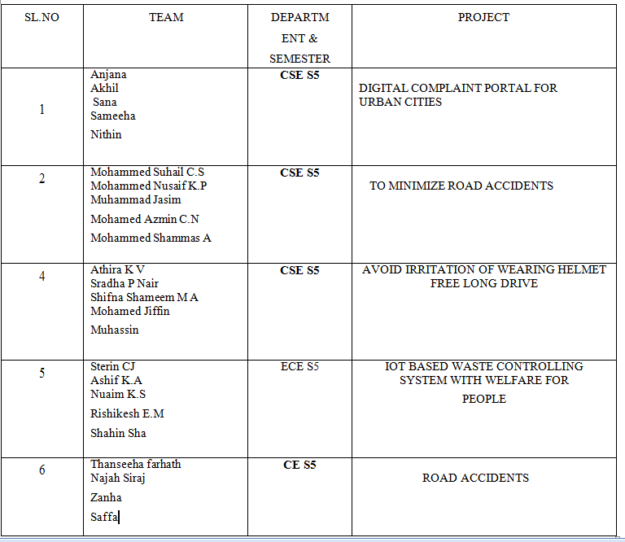

The Prototypes developed by students are listed below
1.SMART BIN
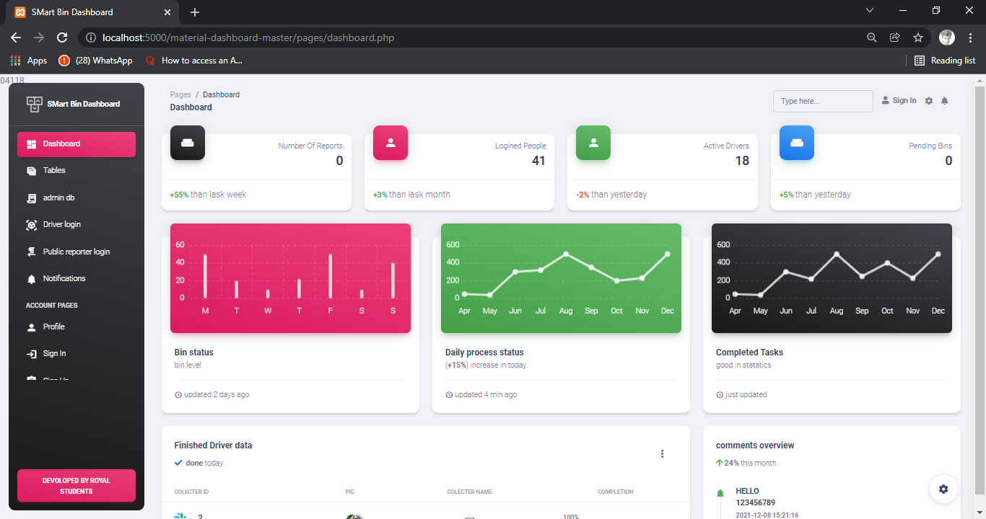

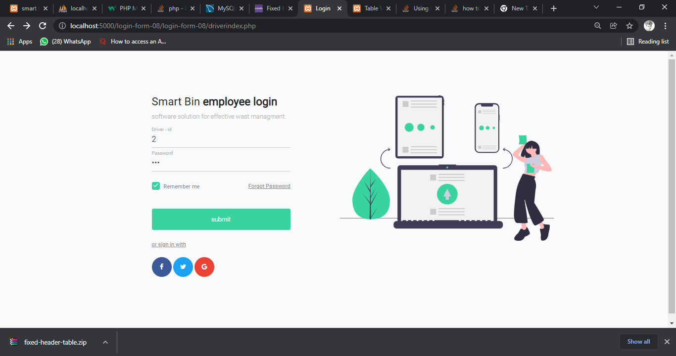

2.SMART HELMET
